**Practical 5**

Name – Ishwari Deshmukh

Class – A4 (B3)

Roll no. – 45

Aim: Implement a dynamic algorithm for Longest Common Subsequence (LCS) to find the

length and LCS for DNA sequences.

Problem Statement:

DNA sequences can be viewed as strings of A, C, G, and T characters, which

represent nucleotides. Finding the similarities between two DNA sequences are an

important computation performed in bioinformatics.

TASK 1: Find the similarity between the given X and Y sequence.

X=AGCCCTAAGGGCTACCTAGCTT

Y= GACAGCCTACAAGCGTTAGCTTG

Code -

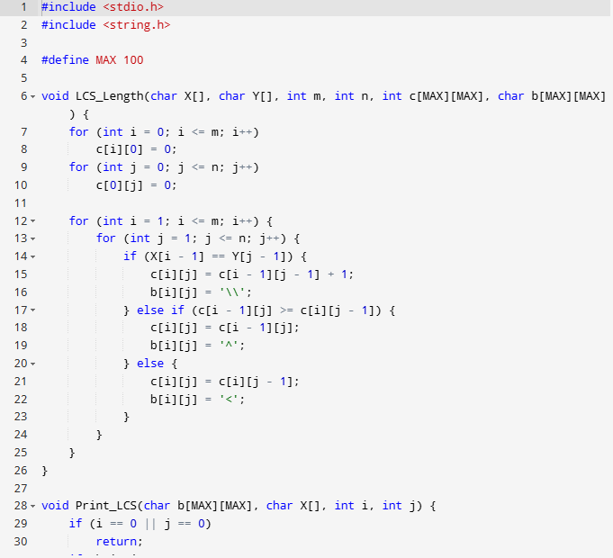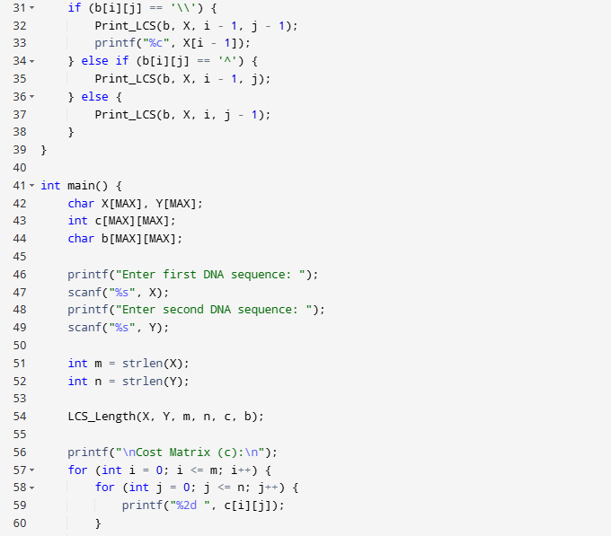

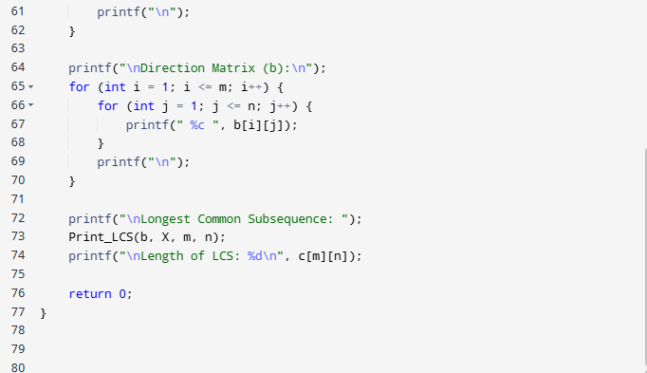

Output –

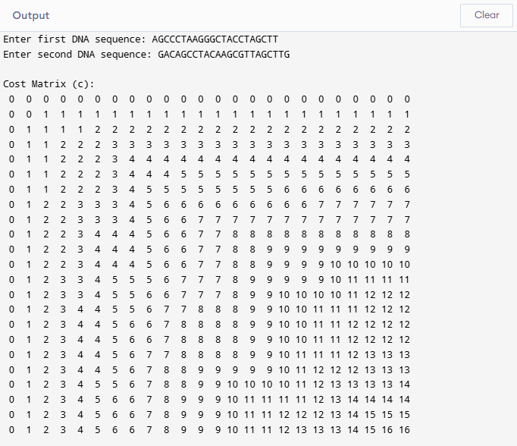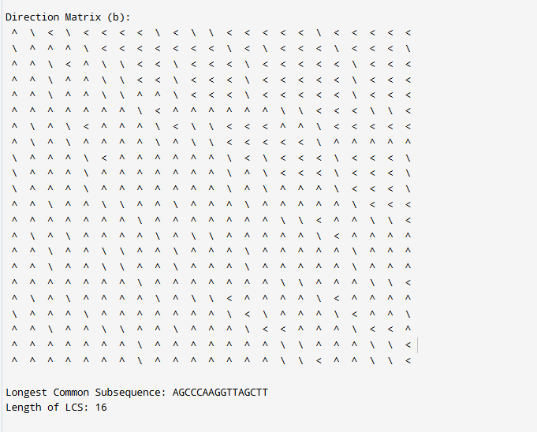

TASK-2: Find the longest repeating subsequence (LRS). Consider it as a variation of the

longest common subsequence (LCS) problem.

Let the given string be S. You need to find the LRS within S. To use the LCS framework, you

effectively compare S with itself. So, consider string1 = S and string2 = S.

Example:

AABCBDC

LRS= ABC or ABD

Code –

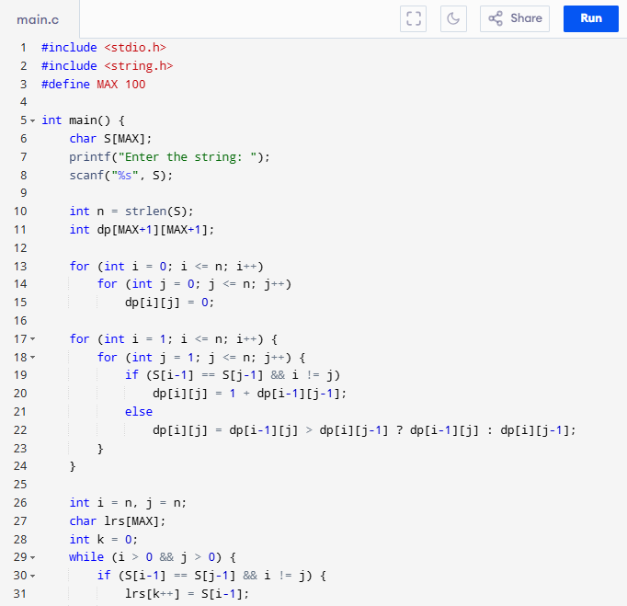

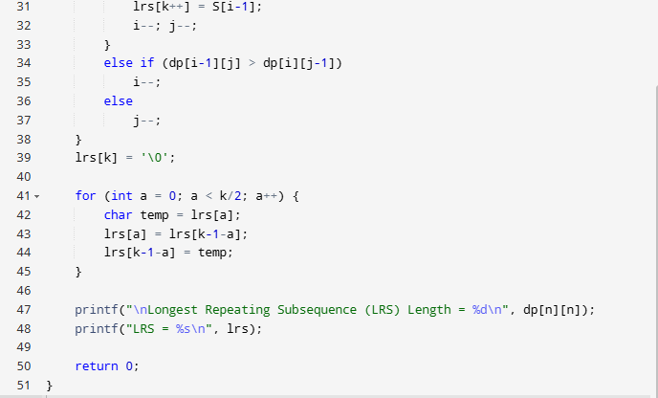

Output –

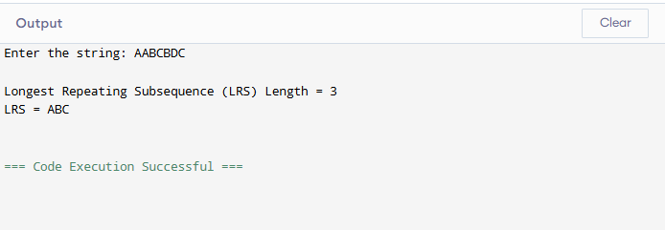

Leetcode Submission –

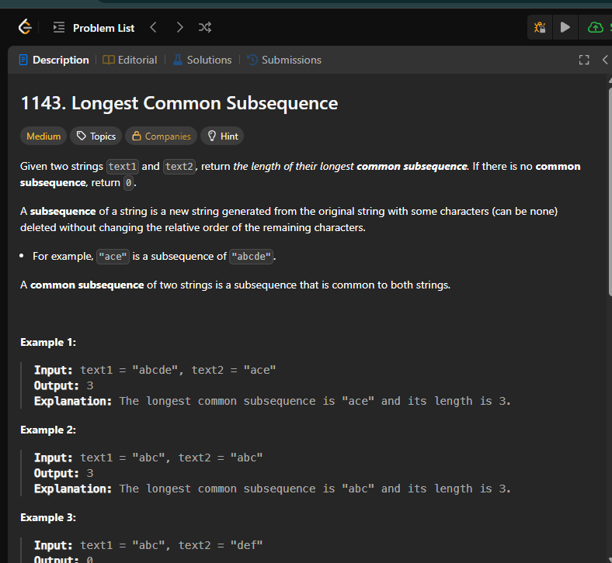

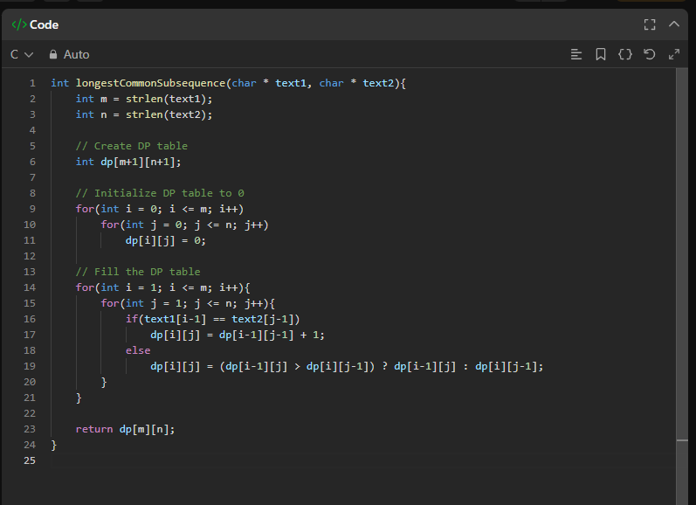

Output-

